**Shell Programming in Linux**

**Program 1**

**Aim -** Find the factorial of a number

**Pseudocode –**

Pseudo code for Factorial of a number :

Step 1: Declare N and F as integer variable.

Step 2: Initialize F=1.

Step 2: Enter the value of N.

Step 3: Check whether N>0, if not then F=1.

Step 4: If yes then, F=F*N.

Step 5: Decrease the value of N by 1 .

Step 6: Repeat step 4 and 5 until N=0.

**Code -**

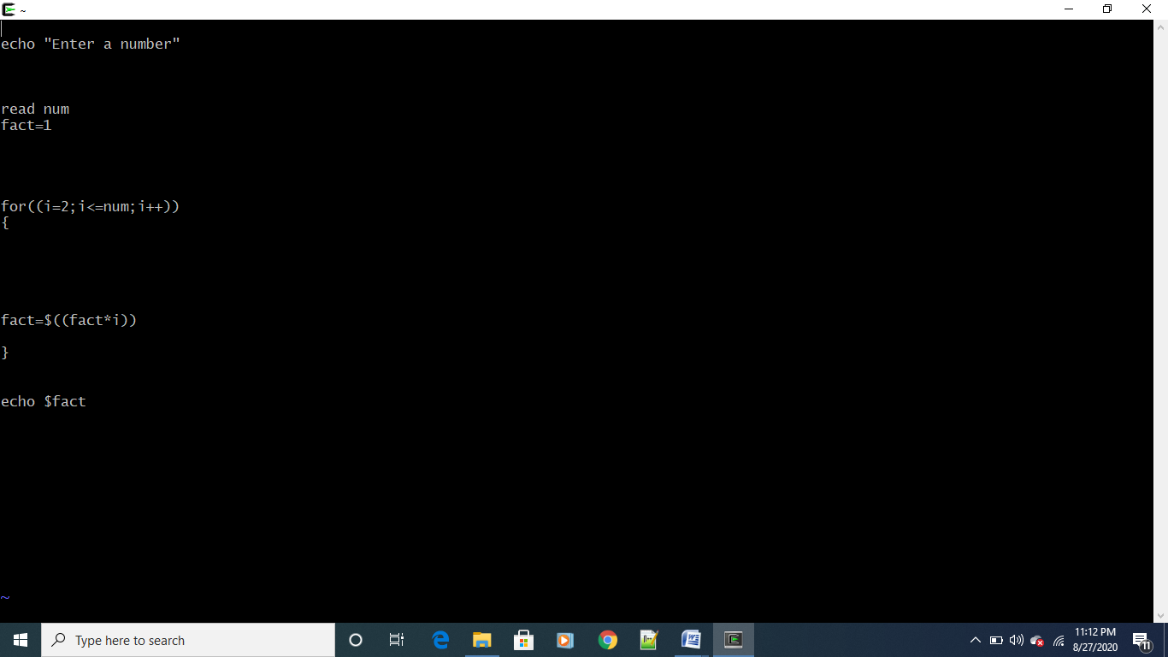

**Output –**

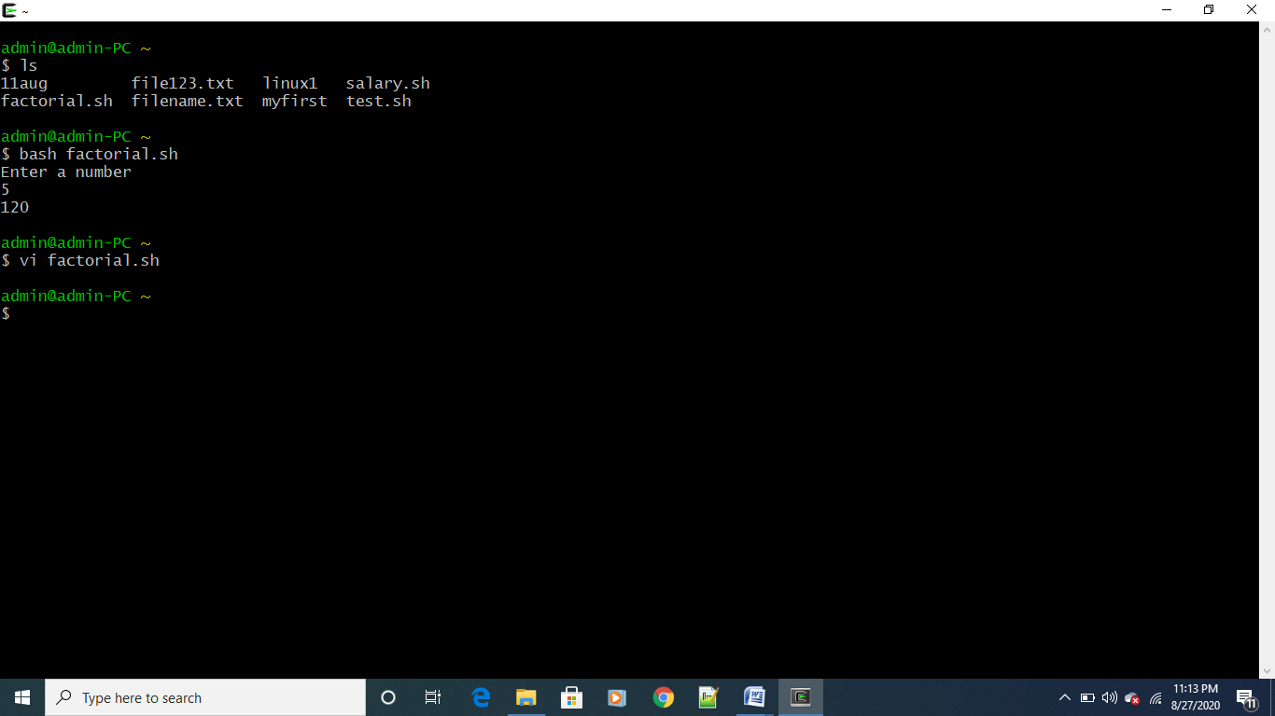

**Program 2 –**

**Aim -** Find the gross salary of an employee

**Code –**

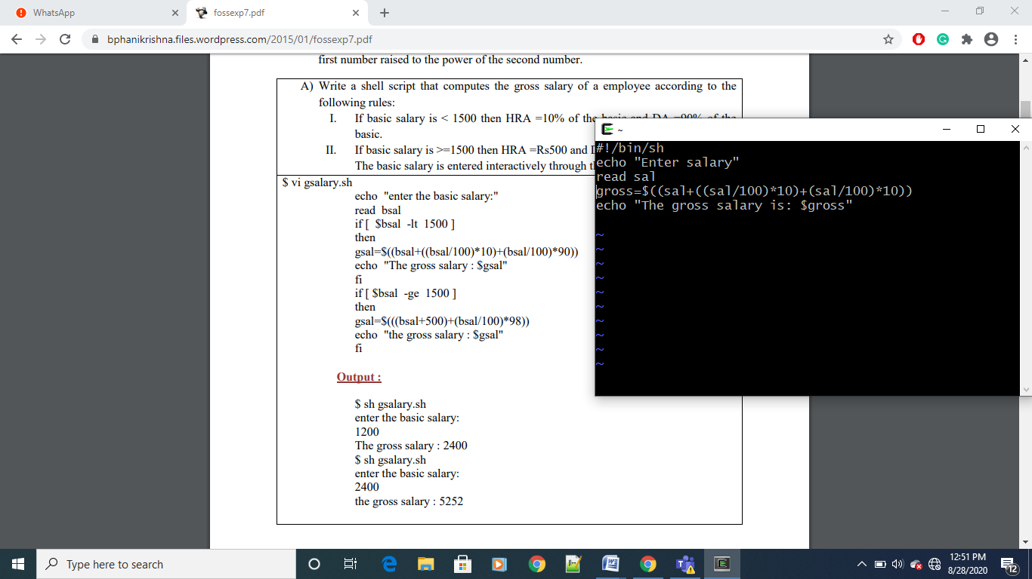

**Output –**

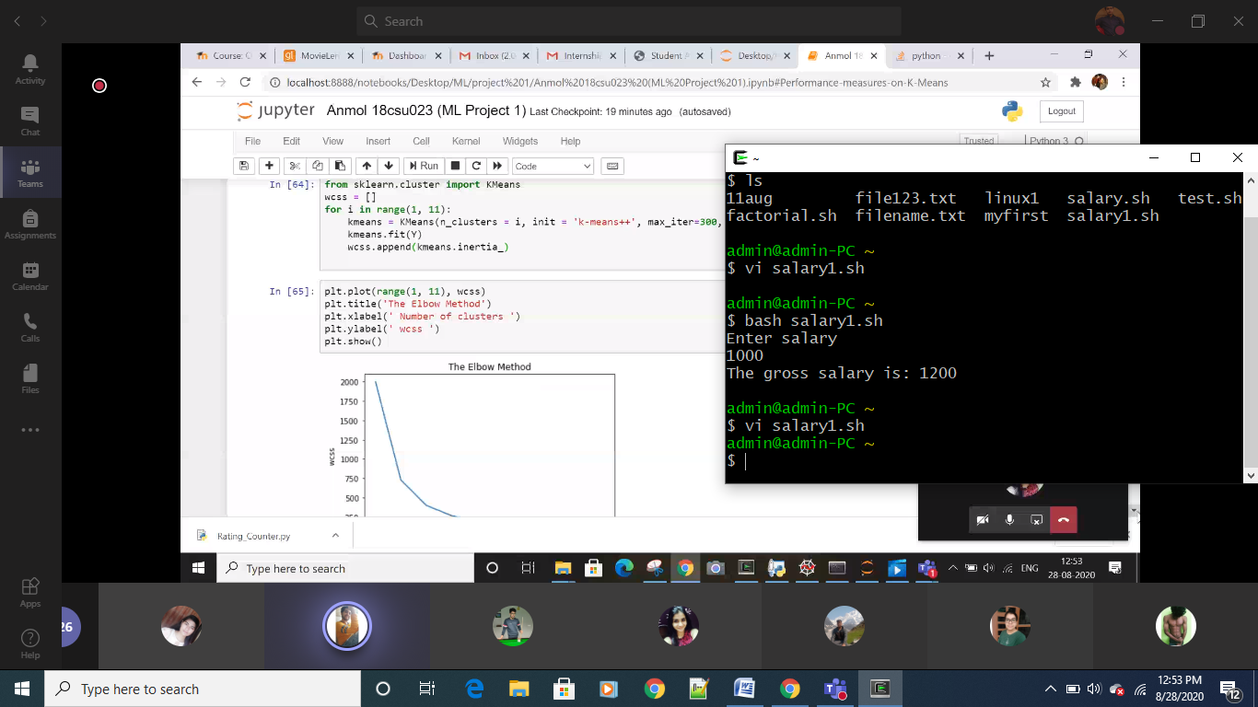

**Program 3 –**

**Aim -** Find Fibonacci series upto a given number.

**Pseudo Code –**

1. Step 1: Start
2. Step 2: Declare variable a,b,c,n,i
3. Step 3: Initialize variable a=1, b=1, i=2
4. Step 4: Read n from user
5. Step 5: Print a and b
6. Step 6: Repeat until i&lt;n

6.1 c=a+b

6.2 print c

6.3 a=b, b=c

6.4 i=i+1

1. Stop 7: Stop

**Code –**

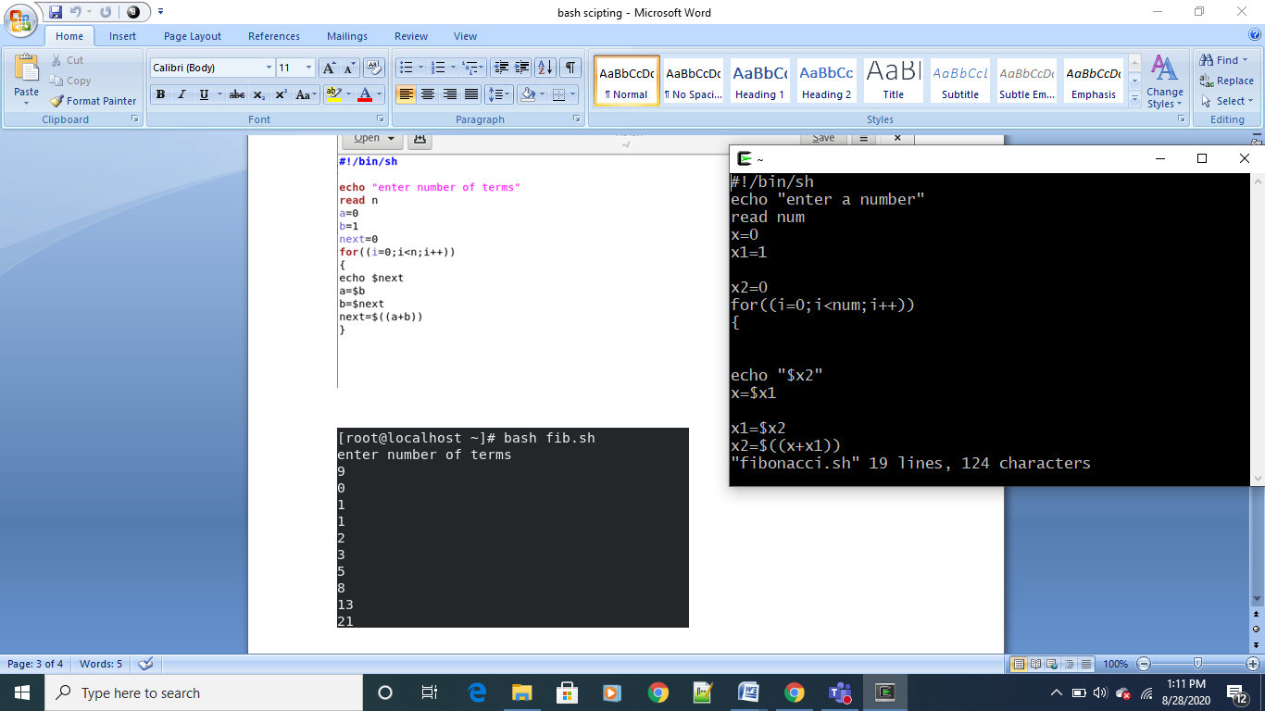

**Output –**

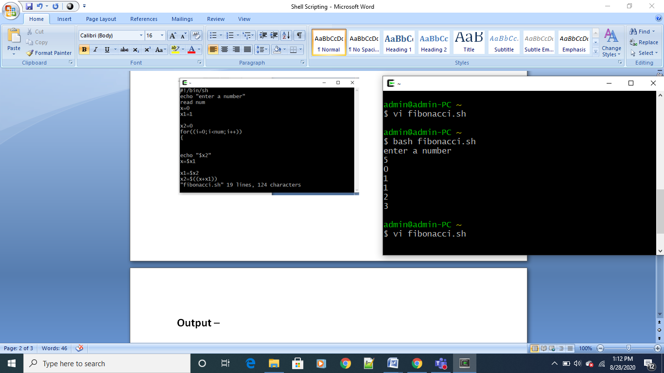

**Program 4**

**Aim -** Find average of numbers

**Code –**

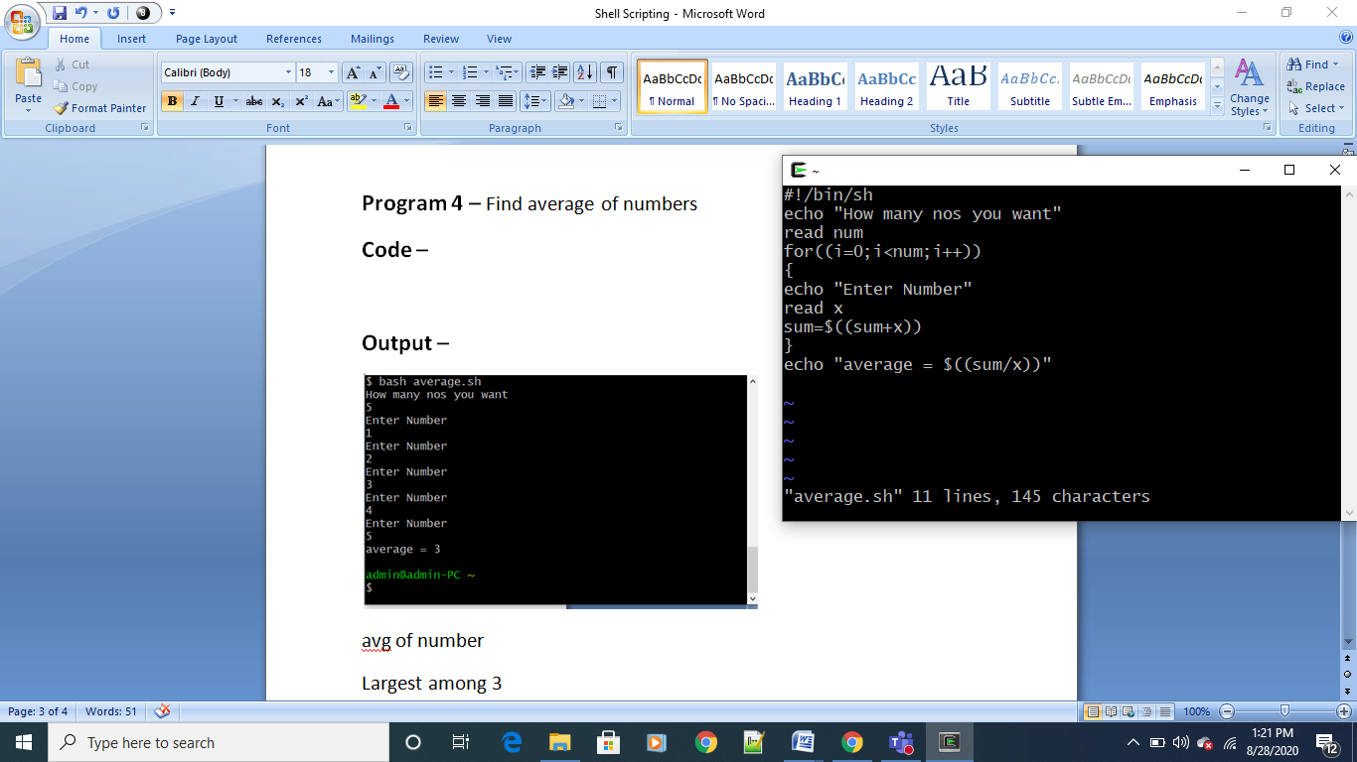

**Output –**

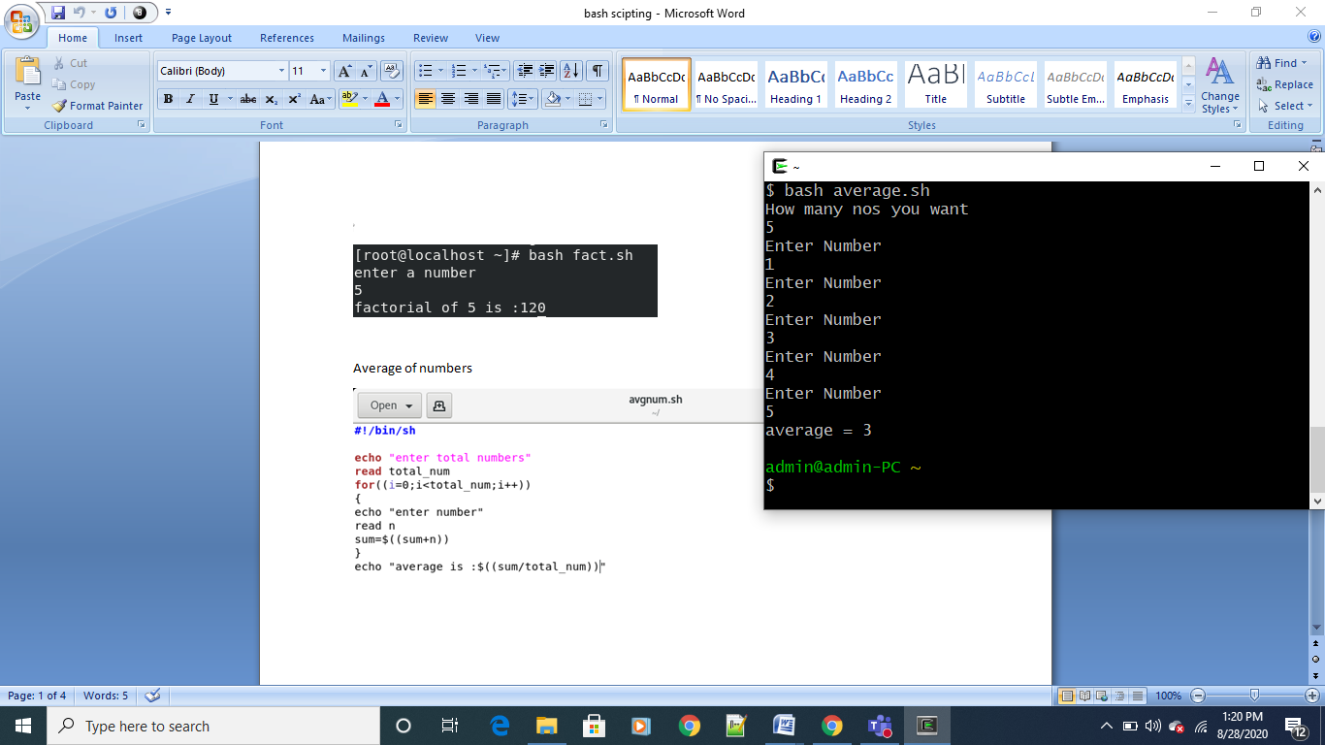

**Program 5**

**Aim -** Find largest among 3

**Code -**

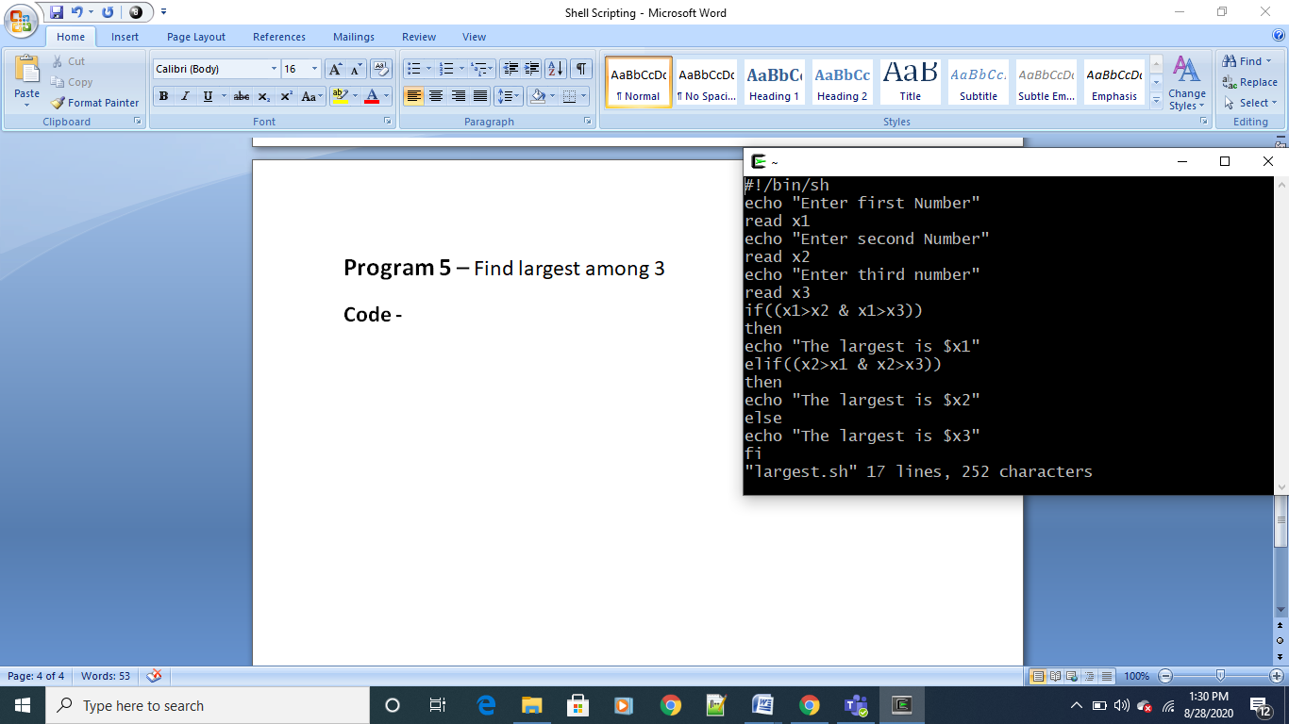

**Output -**

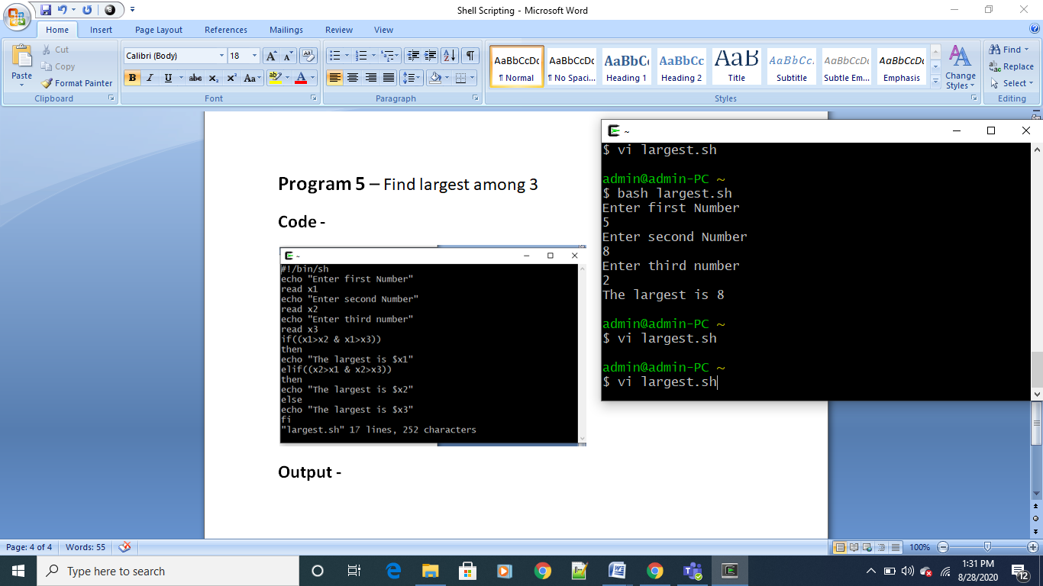

**Program 6**

**Aim -** To perform actions according to given menu

**Code –**

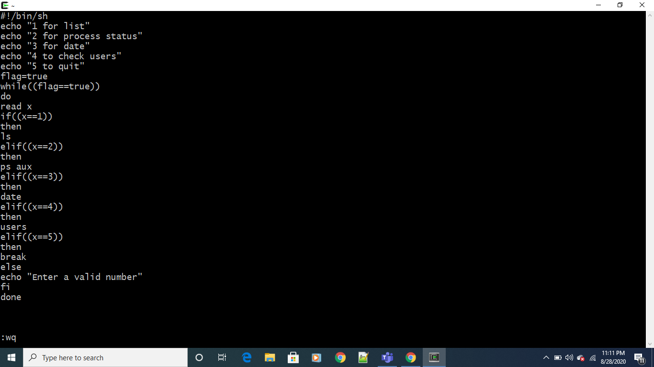

**Output –**

